Elisabeth Ann (Elisa) BROWN 1810-1827
A Tragic Love Story

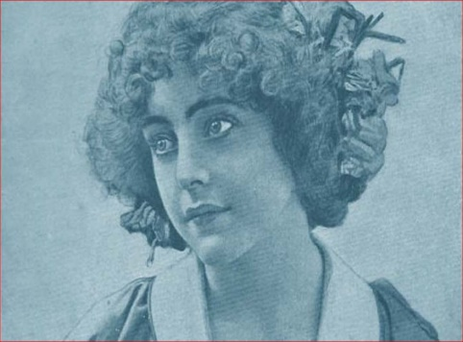
Elisa was the daughter of Admiral William (Guillermo) Brown, hero of Argentina and his wife Elisabeth Chitty, our 1st cousin 5x removed, making Elisa our 2nd cousin removed. We share a 5th great grandfather in Jarvis Curling (1732-1796). The following is the tragic love story of Elisa and Captain Francis Drummond by the El Cementerio Britanico communica:

There are those who affirm that on full moon nights a girl dressed as a bride walks along the banks of the Riachuelo in the Buenos Aires neighbourhood. Dragging her beautiful dress across the sand, the ghost of Elisa Brown, “the silver bride”, laments the tragic outcome of her love life. This is the life immersed in love and death of the daughter of Admiral Brown. One of the most moving stories in Argentine history.
“A perfect family”
Elisa was born with our country... in 1810, although in English lands. However, her tragic life would provide her to shape the written pages of national history.
At the beginning of the 19th century, his entire family left England and settled in Buenos Aires. There, his father, Guillermo Brown, would become the leader of the recent Argentine Navy, and a hero of our independence.
Elisa grew up between the needlework taught to her by her mother, Elizabeth Chitty, and the passion for the sea, which she inherited from her father.
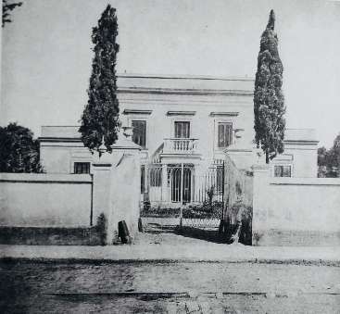
The Browns settled in the southern neighbourhood of Barracas, where along with the classic leather slave barracks, the sumptuous residences of the most important families in Buenos Aires society were built.
Cannon House or the "Yellow House", as the luxurious residence of Admiral Brown was known, was the scene where the love story of Elisa Brown, barely seventeen years old, and the Scottish sailor Francis Drumond, twenty-four, who arrived to his life by the hand of Captain Coe, friend and companion of his father.
“Love at war’’
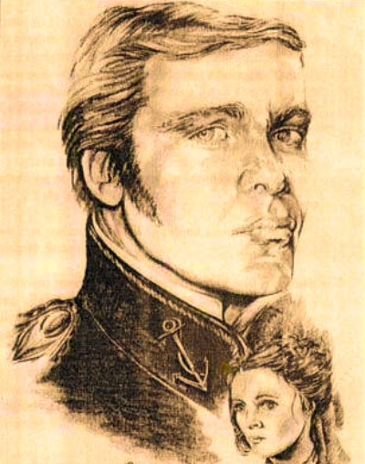
Francis was born in Dundee, Scotland, in 1803. His family had a military tradition. Son of Captain Francis Drummond and Chatarine Young, they belonged to the elite of Forfar. His ancestors had served various causes, and his father and all four of his brothers had been killed in combat.
In full youth he travelled to America. When he arrived, he voluntarily joined the forces of Admiral Brown. He was very handsome and made several women sigh, however, while staying at Cannon House, he met and fell completely in love with Elisa. The love so strong that they lived between the two of them made them get engaged a few months later. Sadly, their warm and promising romance was soon interrupted by the war.
On April 6, 1827, Francis marched into combat with Brown's fleet, while Elisa embroidered her elaborate wedding dress.
“Heroism to the end”
At sea, Francis' luck would take a radical turn. At that time, the Argentine Republic was at war with the Empire of Brazil, and Drummond attended the Battle of Monte Santiago, as commander of the ship "Bergantino Independencia". The disadvantage with the neighbouring country was abysmal. The soldiers had to defend themselves with only three ships, which faced the sixteen Brazilian ships.

In battle, the lover stood out for his courage, he was a true lion on the deck of his ship. When in the middle of a bombardment they ran out of ammunition, he ordered the guns loaded with chain links. Do everything… except give up.
Despite the fact that the Brazilians were winning, Drummond never stopped fighting, but in the midst of the smoke that clouded the space, a splinter tore off one of his ears. Badly wounded, he didn't stop giving orders... and keep fighting.
“All for his daughter... but it was too late”
Seeing that Drummond's life was in danger, Admiral Brown, from another ship, the Sarandí, ordered him through signals with flags to abandon the ship immediately, first burning its hull so that it would not fall into the hands of the enemy.
However, Francisco continued to fight, took a boat and, in the midst of the heat of the fight, made his way to the Sarandí to ask his admiral for more ammunition and his authorization not to abandon the fight. Seeing them, the enemy ships unloaded all the ammunition against the small boat, blowing the boat to pieces.
The boyfriend, this time mortally wounded, is rescued by his compatriots, who take him aboard the third Argentine ship, the Republic. There, they put him to bed in the bunk of Juan Coe, the young captain of that ship. Drummond came face to face with death, and with his dying breath, he fulfilled his heroic duties. He spoke a few words that carefully avoided complaint; he gave his friend, Captain Coe, the wedding ring to give to Elisa, and managed to stay alive until the arrival of the admiral himself, in whose arms… he closed his eyes.
“Daughter; your love has died”
It was the Admiral himself who had to take charge of breaking the sad news to his daughter. They say that Elisa did not emit the slightest adverse reaction and continued to embroider her wedding dress, as if nothing had happened. Then she squeezed her ring tightly, kissed it tirelessly, and left in silence. Everyone at Cannon House believed that the young woman had just slipped into a silent dementia.

"Silver Bride"
On the morning of December 27, the date the young couple had marked their wedding, Elisa dressed in her wedding dress, the one she had embroidered with such care... and walked towards the banks of the Riachuelo.
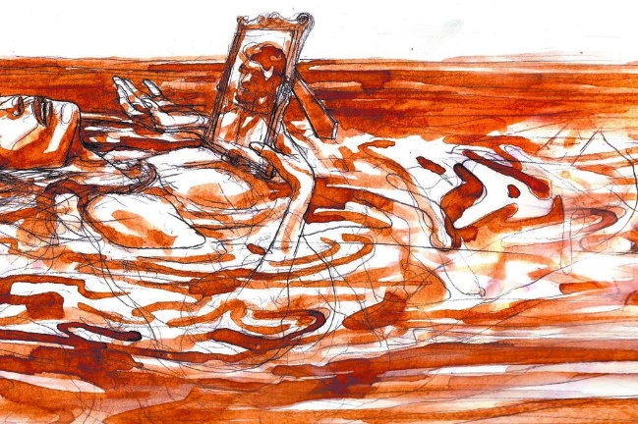
It was his brother Enrique who warned of the tragedy, who from the vantage point of the yellow house could see his sister's body floating on the waters of La Plata wrapped in her immaculate white dress. The young woman, tormented by the loss of her beloved, had just given her life to the sea that her father loved so much.
The admiral was never able to recover from the tragedy. For many years he was seen dressed in black, standing in the doorway of his house, staring into the distance. The garden of the house later became the Elisa Brown square, a modest tribute that the city paid him.
Today, the legend of the ghost of Elisa Brown makes up one more attraction to the picturesque neighbourhood of Barracas, while her body rests next to that of her lover in the British Cemetery.

https://gruporadialcentro.com.ar/elisa-brown-la-que-murio-de-amor/
Images From:
https://www.losandes.com.ar/drummond-el-tragico-latigo-de-su-muerte/
https://brownonline.com.ar/80134-sociedad-la-tragica-historia-de-la-joven-elisa-la-hija-de-almirante-brown-y-su-prometido-2021-03/
https://laurbedigital.com.ar/noticias/2019/02/22/la-historia-francisco-drummond-cuyo-nombre-distingue-una-centrica-calle-adrogue/

